General Information

These standards are for the Metal and Mechs division of Adient. The standards will in some areas incorporate items from Adient Gage Standards Rev 003 dated 5/5/04.

The Scope, General Requirements, Safety, Ergonomic Requirements and Quotation Requirement will not changes.

Material being used for all contact points on the gage must have a hardness of 58 to 62 R/C. All non contact points must have a R/C 38 to 42.

Aluminum material being used for fixtures or forms must be Grade 6160 material, and not wear when being use in conjunction with a steel gage pin.

Base and handles must follow the specification in Adient Gage Standard Rev 003, dated 5/5/04.

The gage design must be signed off by a Adient representative before any steel can be cut. The final gage must be reviewed and also signed off before gage can be used and shipped. A reminder that a part is required for the final buy off of gage.

In all cases until other wise specified and signed off the Drawing is Master, the CAD model can be used in the design and for dimension not on the drawing.

The gage design requires that all CC and SC on the drawing must be in the gage and variable, all other features must be in gage as attribute unless sign off . If no CC or SC are on the drawing then Adient representative must identify the items to be in the gage. Gages are required on all parts. General note section: profile 2.0/A/B/C if shown as CC or SC will be Attribute.

Datum Pins should be RFS 4 way and RFS 2 way spring loaded, MMC pins can be use but must have approval from Adient representative.

See Appendix B for special gagging required for extrudes (for fasterners)

GAGE DESIGN REQUIREMENTS

CONCEPT DRAWING

NOTE: The concept drawing/design will be required on an “as needed” basis as dictated by the Adient representative.

- The Concept drawing is to be drawn on an 8.5" x 11" sheet of paper.
- The Concept drawing must show the “Gage Intent.” It should reflect the Geometric Dimensioning and Tolerance (GDT) scheme and any special requirements reviewed at the quotation meeting. It should show approximate base size, part orientation, location of datum, location and orientation of clamps, location of flush rails / feeler rails, and location of SPC ports. The concept must be labeled with the Adient gage number and gage description.
- The concept review and approval DOES NOT give the authority to order gage materials. As shown in the Gage Design Requirements – Section B. Gage Design, item #11, approval of the gage design authorizes the ordering of materials and components. If gage materials have been ordered prior to final design approval, and changes are made to the gage design that affect these materials, the material costs for the unusable stock will be absorbed by the Supplier.

Go to Table of Contents

GAGE DESIGN

- All gage designs produced for Adient must be computer generated. All designs must be in IGES format, both wire frame and surface data included. Whenever possible, the fixture must be designed using solid modeling software for proper interpretations during design signoffs.
- The gage design is intended to be an accurate representation of the gage. It should reflect how the gage will be constructed and must include the basic information such as, base size and type, part orientation, location, size and orientation of all stanchions, details and clamps, size and location of datum, location of flush rails / feeler rails, and location of SPC ports. It must have all necessary section cuts to show detail and any required blow up sections. Also, all internally manufactured “one-of-a-kind” components need to be drawn and dimensioned on the design.
- Datum that are located on or near parting lines, gates, ejector pins, welds or any similar features must be brought to the attention of the Adient representative for correction.
- All stock items should be commercially purchased whenever possible.
- All designs must have an isometric view of the gage on the design.
- All designs must list all parts (assemblies, subassemblies or versions) that can be verified on the gage. Part numbers that are referenced must be the less finish part number(s) without color designation.
- All designs will be drawn and dimensioned using the metric system (except Standard English stock sizes) unless otherwise specified by the Adient representative.
- Each design must have three Tooling balls with start coordinates labeled on the gage base. If a gage is to be sub-based, there must be three tooling balls on each base.
- All datum surfaces and locators must be labeled on the design with the respective GDT datum callout.
- When a slot or similar feature is used as a Regardless of Feature Size (RFS) 4-way locator, it must be so designed as to allow each locating feature to move independently.
- All Pins and Blocks used for part inspection (i.e. go/no go pin, plug gage, virtual condition pin) must be labeled on the design with their respective size as well as the calculation(s) used to obtain that size.
- If the design reflects a coordinate system other than the automotive X, Y, Z system, then the design must be clearly identified with the appropriate coordinate references (i.e. H, W, L).
- If the part is to be positioned in a different coordinate system than the CAD model (tool die draw or workline verses body position), the design must be labeled in a distinct manner with the appropriate rotation points and angles to move to and from the original system. Return to Gage Build Requirements – Section N. Labeling, item #3
- The design must show the storage locations for removable details or interchangeable details, and loose components (SPC Indicator, GO-NOGO pins, Plug gages). Also, when loose details or components are needed, a general note for tethering of the details is required to be on the design. Return to Gage Build Requirements – Section E. Removable Details, item #1
- The design must reflect the proper clearance for dimensional layout inspection. Reference Quotation Requirements – Item # 4.
- The Adient representative must approve the initial gage design and subsequent design changes. It is recommended that two reviews take place – one at or about 50% completion and one at 100% completion. The design does not have to be signed at the 50% review, but must be for the 100% review. The Adient representative must sign the final design. Other signatures may be required, as dictated by the customer design standards and/or the Adient representative. It is the Supplier’s responsibility to notify the Adient representative prior to completing the design to determine who is required to sign the final design.
- Design approval gives the authority for the Supplier to order gage materials. If materials have been ordered prior to final design approval and changes are made to the gage design that affect these materials, the material costs for the unusable stock will be absorbed by the Supplier. Return to Gage Design Requirements – Section A. Concept Drawing, item #3
- All design changes must be recorded in a standard change column on the design.
- All gage details must be confined within the boundaries of the base.
- The approved (signed) design is the property of Adient and will be stored at the Supplier. An electronic copy (and hard copy as required by the Adient representative) must be supplied with the gage each time the design is updated. Reference Gage Build Requirements – Section W. Records, Item #2.
- Adient will supply all CAD models in its native format (CATIA, UNIGRAPHICS, etc.). Every effort will be made to minimize the file size while ensuring all the critical data is supplied. All IGES translation errors or problems are the Supplier’s responsibility.
- In the event that the customer requires a manual design, items 2 – 14 above and standard gage design practices apply. The original design must be drawn on Mylar and must be neat and legible.
- Consideration for maximum CMM access must be given when designing the clamp type and location. Horizontal handle or bayonet type clamps should be used when CMM access is a priority.

GAGE BUILD REQUIREMENTS

BASES

- It is the Supplier’s responsibility to ensure that the base meets the flatness, parallelism and squareness tolerances as specified below. The datum scheme for these base measurements is defined as the base bottom as it sits in the horizontal position.
d | 0.10 | A | Per 300 mm²
d | 0.20 | A | Not to exceed over entire base
f | 0.10 | A | Between top and bottom surfaces
o | 0.15 |  | All machined edges

NOTE: All Tolerances specified are in millimeters.
- All edges must be machined square and beveled.
- The base must have the J-Corner identified.
- All Tooling plate bases smaller than 200 in² require four (4) jig feet, one at each corner. Bases between 200 in² and 400 in² require five (5) jig feet, one at each corner and one in the center. Bases larger than 400 in² a cast aluminum base is required. A welded steel base may be used with the approval of the Adient representative. Reference Quotation Requirements – Item # 5.
- Tooling plate bases must be a minimum of 1” thick.
- Cast aluminum, welded aluminum or steel bases must be stress relieved.
- All bases must be of uniform thickness. It is the Supplier’s responsibility to inspect the base for uniformity before construction. If the gage is constructed and the base is found to be varying in thickness, the base will have to be replaced and reconstructed at the expense of the Supplier.

TOOLING BALLS

- Three (3) Tooling balls must be located and identified with the start coordinates on the base of the gage. These balls will be used to establish the origin of the fixture for certification and part layout. Reference Gage Build Requirements – Section D. Details, Item #12, for tooling ball requirements as single point net representations (datum target).
- Tooling ball size will be .500 inch.
- Each Tooling ball must have a protective cover. The cover must not interfere with the start coordinate labels.

Go to Table of Contents

RISERS and STANCHIONS

- The risers and stanchions must be attached to the base securely with a minimum of two (2) dowels and two (2) cap screws unless specified in the design as a removable detail. Reference Gage Build Requirements – Section E. Removable Details.
- Risers and stanchions may be relieved or cut away in certain areas to gain access to the part for dimensional inspection. It is the Supplier’s responsibility to ensure the area(s) that are removed do not affect the integrity or stability of the gage.

Go to Table of Contents

DETAILS

- All details must be attached to the base securely with dowels and cap screws. It is the Supplier’s responsibility to ensure that the correct quantities of dowel and cap screws are used. If the quantity is substandard, the Supplier must fix or replace the detail without costs to Adient. Reference GAGE BUILD REQUIREMENTS – Section E. Removable Details for details that are to be built as removable.
- Details shall not be shimmed during construction.
- Details used as net surfaces must be made of steel. Steel plates located on aluminum details may be used.
- Flush rails, feeler rails and sheet metal representations must be constructed of aluminum or fixture plank. Fixture plank must be sectioned into details no larger than 400 mm in length each.
- A 6 mm gap distance is to be used, unless otherwise specified by the Adient representative customer gage build standards.
- All net details that net around the area of a hole or cutout in the part must have CMM probe clearances cut into the detail. These clearances must be a minimum of five (5) mm deep and two (2) mm bigger than the part feature.
- All plug gages, Go/No Go pins where possible should be mount to the gage base, they must be removable.
- Oval holes or slots in the part requires a Go/No Go Length, Width and Go Full Form, Go/No Go full form is not acceptable.
- All loose details (Plug gages, Go/No Go pins) must be tethered to the gage using chain retractable spring-loaded cases with cable lockouts. These cables may be removed if the detail is to be used when the part is scanned. Where possible mounted underneath gage plate with cable coming thru.
- All noncircular plug gages must be keyed for orientation.
- Unless otherwise specified by the customer, a plug gage located in a bushing and clamped on top will be the method to represent a screw or fastener pin.
- When a single point datum target is required, a tooling ball must be used. The associated clamp must be adjusted to not deform the part. Return to Gage Build Requirements – Section B. Tooling Balls – Item #1
- Each feeler rail must have an associated go/nogo feeler pin that reflects the proper tolerance.
- Special requirement: Head rest slot location must be in gage – Min diameter with min depth of slot and orientation is required between two slots.

Go to Table of Contents

REMOVABLE DETAILS

- All removable details must use hardened bushings and bullet nose dowels. The bushings must be in the detail and the dowels must be in the mating component. Reference Design Requirements – Section B. Gage Design, item #14.
- When there are similar removable details used on the same gage, the details must have a unique locating scheme for each. Each detail and storage location must be clearly labeled or color-coded.
Reference Gage Build Requirements – Section C. Risers and Stanchions – Item #1
Reference Gage Build Requirements – Section D. Details – Item #1

Go to Table of Contents

HINGED DETAILS

- All hinge drop details must be counterbalanced or have a lock out mechanism installed. This also pertains if the gage will be tipped 90° to inspect the part.
- All hinge drop details must have rubber stops installed to prevent damage.

Go to Table of Contents

LOCATING PINS

- All locating pins must be tapered and spring-loaded (RFS pin). The Gage Buyer or Adient representative must approve all other pins (MMC pin, LMC pin).
- All tapered RFS pins must locate the part approximately at the mid point of the taper.
- All locating pins must be made of hardened steel.
- If a locating pin must be locked out to load the part, the lockout mechanism must be positive. For instance, if a detail has an “L” shaped cut to lockout the locating pin, the cut must have enough lead in to disengage the locating pin and hold it out of position.
- The locating pin spring pressure must be strong enough to locate the part without distortion when clamped.
- Spring loaded locating pins must move freely in all directions except the locating direction using graphite lubricant.

Go to Table of Contents

CLAMPS

- All clamps must have a clamp direction of 90° to the part surface.
- Clamps that are spring loaded must have a positive lockout mechanism.
- When clamping over a hole, the clamp foot must be cut to allow access to the hole.
- When engaging a clamp, it must not interfere with the part or any other detail(s) on the gage.
- Clamp pressure must be the minimum required to locate the part, but stronger than the opposing spring-loaded features.
- All clamp pressure feet must be mar-proof. Examples are rubber, neoprene or nylon. If metal clamp feet are required, they must be free of burrs and sharp edges and have a mar-proof coating.

SCRIBE LINES / TOLERANCE BANDS

- All scribe lines and tolerance bands must be scribed or milled into the surface. Painted lines on the surface are not acceptable.
- All scribe lines and tolerance bands must be identified with a distinct color to ensure good visibility for measurement. If a nominal line is included in the tolerance band, the nominal line must be contrasting color within the tolerance band.
- Every effort must be made to minimize or eliminate the effect of the parallax error.
- All gage bases must have bodylines scribed on them. It is recommended that the bodylines are scribed every 100 mm for smaller fixtures and 200 mm for larger fixtures. These bodylines must be labeled with the appropriate body coordinate and left hand (-) or right hand (+) signification.

Form Profile
- Form in all stamping gage for fit and function and must be identified by the part Engineer.
- Normally 6.0mm clearance is specified for profiles, a 3.0mm clearance can be approved by a Adient representative based on available space in gage
- In some cases part design may cause issues with gage design for profile, in these cases each need to reviewed by the Adient representative and signed off.

LINEAR BEARING SLIDES
- It is recommended that linear bearing slides not be used. It is understood that in some cases because of design issue there is no choice. This must be approved prior to or at design review.
- The race track in the design of the slides must be drilled and dowelled not screwed (Ref IKO design)

SPC INDICATORS

- The SPC indicator type to be used on all gages supplied to Adient will be Mitutoyo series 543 or 575. Specific indicator features (resolution, discrimination, travel, and sensitivity) will be dictated by each application.
- Master set blocks will be at a length of 31mm and 50mm for applications that require more CMM access.
- All indicators must be set up to zero out in the approximate center of its travel length. For instance, if an indicator has a 1-inch travel, the indicator must be zeroed out at .5 inch.
- The SPC indicator bushing and port sizes will be 3/8” I.D. and O.D. respectively.
- The check direction of each indicator must be 90º to the surface it is measuring.
- The proper indicator tip must be used for each application. Examples are listed below:
- Ball point / spherical / conical tip – used to check a point on a compound surface or overall length indicating on a Micro slide.
- Flat tip – used to check a part edge that has a radius at the checkpoint.
- Knife blade (chisel) tip – used to check a part edge with a flat contour.
- Indicator extensions should be used sparingly or only as the application dictates. Extensions must be kept to the shortest length possible to obtain an accurate measurement.
- All indicator extensions and tips must be tightened without using lock-tite or other chemical fasteners.
- A feather-light indicator must be used if the inspection point on the part is flexible or touch sensitive.

Go to Table of Contents

BUILD TOLERANCES

NOTE:
- Tolerances are established using the following gage certification datum scheme - the primary datum is the surface plane established by the tooling balls, the secondary datum is the longer line established by the tooling balls and the tertiary datum is the shorter line established by the tooling balls.
- The check direction is defined as the direction(s) in which the part is to be held.
- The non-check direction is defined as the direction(s) that the part is not to be held.
- All tolerances are in millimeters unless otherwise noted.
- Net Surfaces
d | 0.20 | A | B | C | Check direction
d | 1.00 | A | B | C | Non-check direction
- Round Pin Locators (4-way / 2-way)
j | n 0.10 | A | B | C | Check direction
j | n 0.50 | A | B | C | Non-check direction
- All other Locators
j | 0.10 | A | B | C | Check direction
j | 0.50 | A | B | C | Non-check direction
- Attribute rail – flush and/or feeler [vector check]
d | 0.40 | A | B | C
- Attribute rail – flush and/or feeler [set two check one check]
k | 0.40 | A | B | C
- Sheet metal representation
d | 0.30 | A | B | C
- SPC port location
j | n 0.20 | A | B | C | Check direction
j | n 0.50 | A | B | C | Non-check direction

- Scribe lines
k | 0.60 | A | B | C

- Sight checks (painted)
k | 1.00 | A | B | C
- Slides
f | 0.10 | A | B | C | Entire travel
- Check pin location (MMC, LMC or VC pin)
j | n 0.15 | A | B | C | Check direction
- Go Pin size
+0.00 / -0.02
- Nogo Pin size
+0.02 / -0.00

Go to Table of Contents

LABELING

- All labeling on the gage must be legible and descriptive. The labeling must be placed in such a manner that it is readable when the part is on the fixture. Labels may be engraved, printed or stamped. If tags are used, they must be permanently attached to the gage.
- The following detail types must be labeled on the gage:
- All datums (net surfaces and locators)
- Clamp sequence
- Flush rail location and offset measurement
- Feeler rail location and offset measurement
- Go/No Go pin sizes
- Indicator port reference number
- Master set block offset measurement
- Body line references (appropriate customer references – XYZ or LWH)
- Specific measurement locations
- Tooling balls on the base must be clearly labeled with their respective start coordinates. If there are more than three (3) tooling balls on the base, the three (3) that are used to certify the fixture must be labeled with the word “Origin” next to the coordinate. Coordinates will be assumed to be in body position, but if they are in work line or other, they must be clearly identified with the coordinate system used. Reference Gage Design Requirements, Section B. Gage Design, item #12.
- Each gage must have a Supplier Identification tag permanently attached to it. Each tag must be labeled with the following information:
- Supplier name, address and phone number
- Supplier job number
- Customer
- Adient Gage Number (84xxxx)
- Gage Description
- Part Revision Level
- Certification date
- Program name(s) and part name(s)
As Required
- Third party source name, address, phone number and certification date
- List of part numbers and names (if gage checks multiple parts)
- Gage instructions must be affixed to each gage. Reference Gage Build Requirements - Section r. Gage Instructions, item #1.

Go to Table of Contents

CORROSION PROTECTION

- All steel components must be black oxided.
- All non-mating surfaces must be painted with the customer-required color. If a color is not specified, blue is to be used.

Go to Table of Contents

GAGE CERTIFICATION

- It is the Supplier’s responsibility to ensure that the cutter path and certification data are correct. See General Requirements – item #4 & General Requirements to a national standard). One of a kind details, like step blocks or thickness feelers, may be certified with traceable hand held equipment (micrometers, calipers). Purchased inspection details and devices (gage pins, scales, protractors, indicators) may be certified by including the certification report from the manufacturer. If a report is not sent, the detail must be certified using appropriate means.
- The Supplier Internal Certification must use a vector check for all net surfaces, sheet metal representations and compound surfaces. A “set two, check one” check may be used on details that represent a one-direction check like a net point, flush rail, or feeler rail. SPC bushing locations must be verified and reported in the check direction but only verified in the non-check direction. Pin size and location and hole size and location must be verified and reported.
- The number of certification masters developed for each detail is dependent on the size and complexity of the detail. It is the Supplier’s responsibility to develop a sufficient amount of points to demonstrate that the gage is dimensionally correct. As an example, on a typical 25 mm x 25 mm net block, it is recommended that a minimum of five (5) masters be used. There must be enough masters to evaluate any single or combination of elements of size, location, orientation and profile.
- All gage certifications must include a “road map” of the certification points.

Go to Table of Contents

THIRD PARTY CERTIFICATION

- A Third Party Certification is required on all gages that are manufactured by a Supplier who’s certification department IS NOT accredited to a nationally recognized laboratory or inspection standard (i.e. ISO Guide 25 or ISO Guide 17025). This accreditation must be performed by a duly recognized accreditation body (American Association for Laboratory Accreditation – A2LA or equivalent). Certification to the QS9000 or TE9000 standard DOES NOT supersede this requirement; it is in conjunction with it. Refer to the AIAG QS9000 manual paragraph 4.11.2.b.1 for clarification.
This Third Party certification must be performed one of two ways:
- The third party source verifies the certification masters against the CAD model and inspects the gage at the third party facility.
- The third party source develops new certification masters and inspects the gage at the third party facility.
Return to Quotation Requirements – item #1
- During plant verification an issues arises with the gage meeting the GD&T to the certification, the Plant will notify will notify the Gage Supplier of the error found. If the error can not be resolved between the Plant and Supplier, the gage will go to an independent 3rd party and the error is verified the Gage Supplier will be responsible for all cost involved to include repairing the gage

- It is the Supplier’s responsibility to ensure the accuracy and on time delivery of the Third Party Certification.
- If the Third Party Certification is found to be discrepant, it is the Supplier’s responsibility to correct it without cost to Adient, up to and including the internal and Third Party recertification.
Go to Table of Contents

GAGE INSTRUCTIONS

- All gages must have gage instructions attached to the gage. Also, an electronic copy must be supplied on CD upon delivery of the gage. Reference Gage Build Requirements – Section W. - Gage Records, item #2.
- The gage instructions must be detailed and understandable with references to the gage clearly labeled. They must identify the gage preparation, loading, clamping, inspection and unloading of the part. The instructions must include all part configurations. They must include a picture of the gage with the appropriate references identified (locators, net surfaces, check points, etc). Return to Gage Build Requirements – Section N. – Labeling, Item #5

Go to Table of Contents

FUNCTION CHECK

- A function check must be performed prior to delivery of the gage. The Supplier may utilize their own completion checklist, but it must include all the items listed on the gage completion checklist in the appendix. The function check of the gages must consist of the following step as a minimum:
- Evaluate the gage against the gage design.
- Function all components on the gage.
- Using the gage instructions, load the part on the gage.
- Identify and remove all interferences.
- Document the results.
- Correct any discrepancies.
- It is the Supplier’s responsibility to request parts for the function check. If the gage is to be delivered prior to part availability, all items above must be performed, with the exception of items C and D. When parts become available, it is the responsibility of the Supplier to complete function check.

Go to Table of Contents

MEASUREMENT SYSTEMS ANALYSIS

- A Measurement Systems Analysis study (Gage R) must be performed prior to delivery and/or final buy off of the gage. For engineering changes, refer to step #8.
#5 for clarification. The accuracy of the gage must be verified using a certified CMM (traceable to the standards)

The primary function of the gage, when delivered will determine which study is to be performed. Reference matrix below.
- For a single-function gage (CMM holding fixture, SPC gage, Attribute gage), one study must be performed.
- For a single-function gage that will become a multi-function gage (CMM/SPC gage, CMM/Attribute, SPC/Attribute) later in the program, a study must be performed at each build phase.
- For a multifunctional gage that is built from the initial kickoff, only one study is to be performed, of which the easiest variable study takes precedence.
Gage Type | 1st Build | Perform MSA study referring to this Step # below | 2nd Build | Perform MSA study referring to this Step # below
CMM holding fixture | C | 2.1.1 | N/A | N/A
SPC gage | S | 2.1.2 | N/A | N/A
Attribute gage | A | 3.1.1 | N/A | N/A
CMM - SPC gage | C - S | 2.1.2 | N/A | N/A
CMM - SPC gage | C | 2.1.1 | S | 2.1.2
CMM – Attribute gage | C - A | 2.1.1 | N/A | N/A
CMM – Attribute gage | C | 2.1.1 | A | 3.1.1
CMM - SPC – Attribute gage | C – S - A | 2.1.2 | N/A | N/A
CMM - SPC – Attribute gage | C | 2.1.1 | S – A | 2.1.2
SPC – Attribute gage | S - A | 2.1.2 | N/A | N/A
SPC – Attribute gage | S | 2.1.2 | A | 3.1.1
Key: C = CMM holding fixture S = SPC gage A = Attribute gage
- The Gage R study will use one (1) operator loading one (1) part ten (10) times.
  - The study must be performed one of two ways as listed below:
    - CMM HOLDING FIXTURE
- Obtain one (1) part from the Adient representative.
- Using the Drawing, obtain nine (9) body coordinate points, three in each direction (X, Y, and Z) to show the most variation in each axis.
NOTE: The Adient representative may choose the points for the study or consensus must be gained from the Adient representatives to use the points chosen by the Supplier. It is preferred that each point be on an edge to allow the CMM to “shank” check the part, checking only in the primary check direction. GR Study Coordinates
- Using the gage instructions, load the part on the gage.
- Using a CMM, measure each of the body coordinates. Record the deviation from the master check direction for each coordinate.
- Unload the part.
- Repeat steps C–E until the ten (10) trials are complete.
- Input data into form, calculate and analyze the result.
- If study is found to be unacceptable, the Adient representative and the Supplier must jointly determine the improvements needed to obtain an acceptable result.
    - SPC GAGE
- Obtain a part from the Adient representative.
- Using the gage instructions, load the part on the gage.
- Measure each SPC location. Record the measurement(s).
- Unload the part.
- Repeat until the ten (10) readings at each SPC location have been obtained.
- Input data into form, calculate and analyze the result.
- If study is found to be unacceptable, the Adient representative and the Supplier must jointly determine the improvements needed to obtain an acceptable result.

  - Acceptance criteria for the study will be as follows:
>20% | Will not be accepted without approval from the Adient representative.
10% - 20% | Borderline acceptable. Must investigate cost and timing impact to improve measurement system. Adient representative must approve plan.

0% - 10% | Acceptable.
- The Attribute study will use three (3) operators loading Fifty (50) parts three (3) times each.
  - The Attribute study must be performed as listed below:
    - ATTRIBUTE GAGE
- Obtain fifty (50) parts from the Adient representative.
NOTE: The parts used in this study should represent acceptable and rejectable parts. If the Adient representative deems acceptable, the parts may be modified (trim or sand an edge, ream a hole) to ensure that the parts are rejectable.
- Using the gage instructions, load a part on the gage.
- Using all the attribute inspection devices, measure the part. Record the inspection result for each device.
- Unload the part.
- Repeat steps B-D until the Fifty (50) parts have been measured, first operator.
- Repeat steps B-D until the Fifty (50) parts have been measured, second operator.
- Repeat steps B-D until the Fifty (50) parts have been measured, third operator.
- Input data into form, calculate and analyze the result.
- If study is found to be unacceptable, the Adient representative and the Supplier must jointly determine the improvements needed to obtain an acceptable result.
  - Acceptance criteria for the Attribute study will be as follows:
PASS | Acceptable
FAIL | Will not be accepted without approval from the Adient representative.

- If an engineering change is completed that affects the locating or measurement scheme of the gage, the Measurement Systems Analysis process must be re-verified. If the engineering change is in question, it is the Suppliers’ responsibility to contact the Adient representative for clarification.
- Completion of the Gage R study or Attribute study does not waive the Supplier’s responsibility to repair or adjust the gage (at no cost to Adient) if the Gage Repeatability and Reproducibility study or Attribute study required for PPAP is unacceptable. The Adient representative and the Supplier must jointly determine the improvements needed to obtain an acceptable result.

Go to Table of Contents

SHIPPING / TRANSPORTATION

- All gages must be completely protected from the elements when being shipped.
- All gages must be secured when shipped.
- Adient will accept full responsibility of the gage when it is delivered and unloaded at Adient’s receiving location.

Go to Table of Contents

PREVENTIVE MAINTENANCE INSTRUCTIONS

- All gages must have Preventive Maintenance instructions supplied electronically on the CD upon delivery.
- The Preventive Maintenance instructions must be detailed and understandable with references to the gage clearly labeled. They must identify the maintenance instructions, recommended frequency of maintenance, recommended chemicals / solutions to use for maintenance and long-term storage preparation instructions. NOTE: If the chemicals / solutions cannot be purchased “over the counter”, then a hardcopy of the MSDS sheet must be included with the gage upon delivery.

Go to Table of Contents

RECORDS

- The Supplier is responsible to provide an itemized Gage Timing chart for each gage from initial kickoff to delivery on a periodic basis. The report will be due every week but may be modified by the Adient representative. Delays in program timing must be reported immediately, first verbally, then on the hardcopy timeline. For gages with total timing of less than three (3) weeks, no timeline is required.
- The Supplier is responsible to provide two (2) electronic copies of the latest documents and data on a Compact Disk each time the gage is modified*. One copy will be attached to the gage and the other will be delivered to the Adient representative. This disk must contain the following:

- Native CAD model
- Gage Design
- Gage Certification
- Gage R and R /or Attribute study Gage
- Digital picture of the gage
- Any other pertinent documents as required
- Final gage timeline - OPTIONAL
- Final gage checklist - OPTIONAL
- Modified is defined as any change to the fixture or its documents due to a Adient or OEM directed change, repair, correction, etc. All modifications do NOT necessarily constitute a Adient representative level change.
Return to Gage Design Requirements – Section B. Gage Design, Item #21
Return to Gage Build Requirements – Section R. Gage Instructions, Item #2
- The CD jacket must be labeled with the Supplier name, Supplier job number, Adient’s Tool Number, Gage Description, and revision level.
- All documents that require signed approval will be in original hard copy format and kept at the Supplier.

Go to Table of Contents

SPECIALTY GAGING

NOTE: Specialty Gaging is defined as any fixture or gage that employs the use of non-contact or technologically advanced devices used in place of more commonly used analog devices. Examples may include Lasers probes, Vision systems, or Magnetic systems.

- The Supplier is responsible to prove-out and validate Specialty Gaging using the same methods as a fixture or gage as defined in this standard. In addition, the Supplier is responsible to verify all software applications and/or written code provided with the gage. This verification is to be performed by testing the input and output relationships and results with a minimum of 3 replications on 10 different parts. This verification study must be documented and supplied with the gage.
- Specialty gages must meet the Adient Special Equipment General Specifications (SEGS) and Special Equipment Safety Specifications (SESS) as well as any applicable industry standards that may not be covered in the SESS and SEGS documents. If aspects of these manuals are in question, contact the Adient representative or Capital Equipment Buyer for clarification.

Go to Table of Contents

AUTOMATED and SEMI-AUTOMATED GAGING

NOTE: Automated Gaging is defined as piece of equipment that is used to assess the acceptability of the part without operator intervention, except for loading and unloading of the part. Semi-Automated Gaging is defined as a piece of equipment that is used to assist the operator in loading, clamping, measurement and/or unloading of the part. Examples for both types of gages may include pneumatic equipment or electronic equipment.

- Prior to design and build of any Automated Gaging, the Adient Representative must complete an Equipment Specification sheet. This sheet will be used in place of the Gage Request for Quote or Gage Assumptions / Cost Model sheet. The Supplier is responsible to meet all requirements of the Equipment Specification.
- The Supplier is responsible to prove-out and validate Automated and Semi-Automated Gaging using the same methods as a fixture or gage as defined in this standard. In addition, the Supplier is responsible to verify all software applications and/or written code provided with the gage. This verification is to be performed by testing the input and output relationships and results with a minimum of 3 replications on 10 different parts. This verification study must be documented and supplied with the gage.
- Automated and Semi-Automated gages must meet the Adient Special Equipment General Specifications (SEGS) and Special Equipment Safety Specifications (SESS) as well as any applicable industry standards that may not be covered in the SESS and SEGS documents. If the Supplier is in need of a copy of these manuals or if aspects of these manuals are in question, contact the Adient representative or Capital Equipment Buyer for clarification.
- The Supplier is responsible for dry cycling the Automated and Semi-Automated gaging. This dry cycle will consist of a continuous 20 hours of operation or as defined by the Adient representative. The dry cycle results must be documented and supplied with the gage.

Appendix A

PROFILE CHECK OF A SURFACE WITH A STEP PIN

A single step or flush pin check for profile of a surface in not acceptable condition.

If a step pin is required then a min of 4 pin equally space can be use so that each area is checked surface area of the profile independently

A feeler type check is recommended.
Part
Gage

Appendix B

Extrude Gagging - Required for all Extrudes
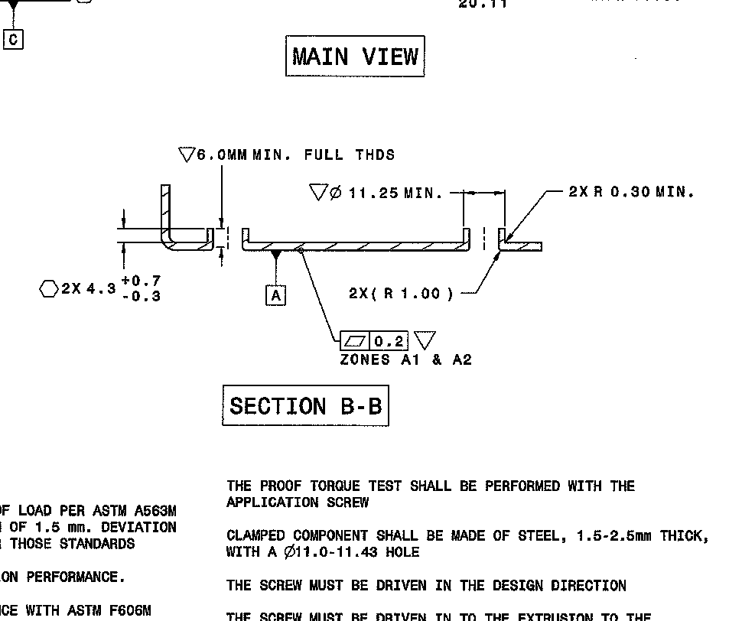
- Min. Diameter – per F. Winters Max diameter 1.0mm larger
- Max ring gage for Max Diameter
- Height of Extrude will be incorpated in ring gage thickness.
- During die run off the extrude will be section in half to verify no void is present.

Gage Required for all headrest - Gage to check slot depth and location to each other and diameter.
Plug gage go/nogo
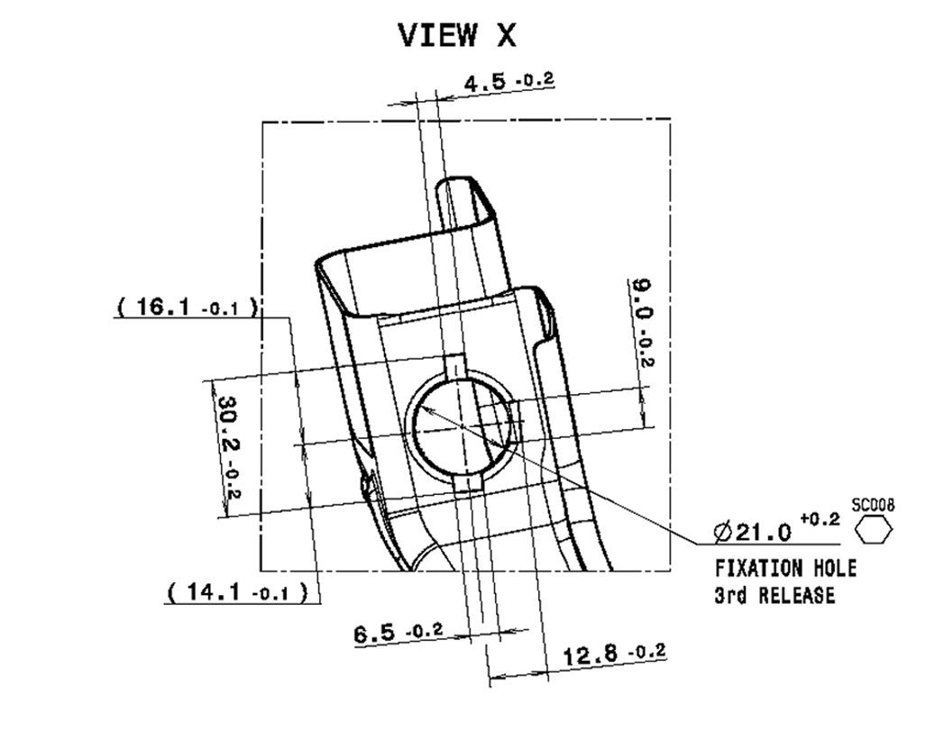
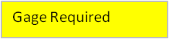

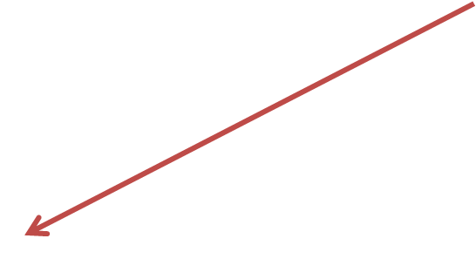



TETHER WIRE TRUE POSITION CHECK BACK TO A/B/C – DESIGN

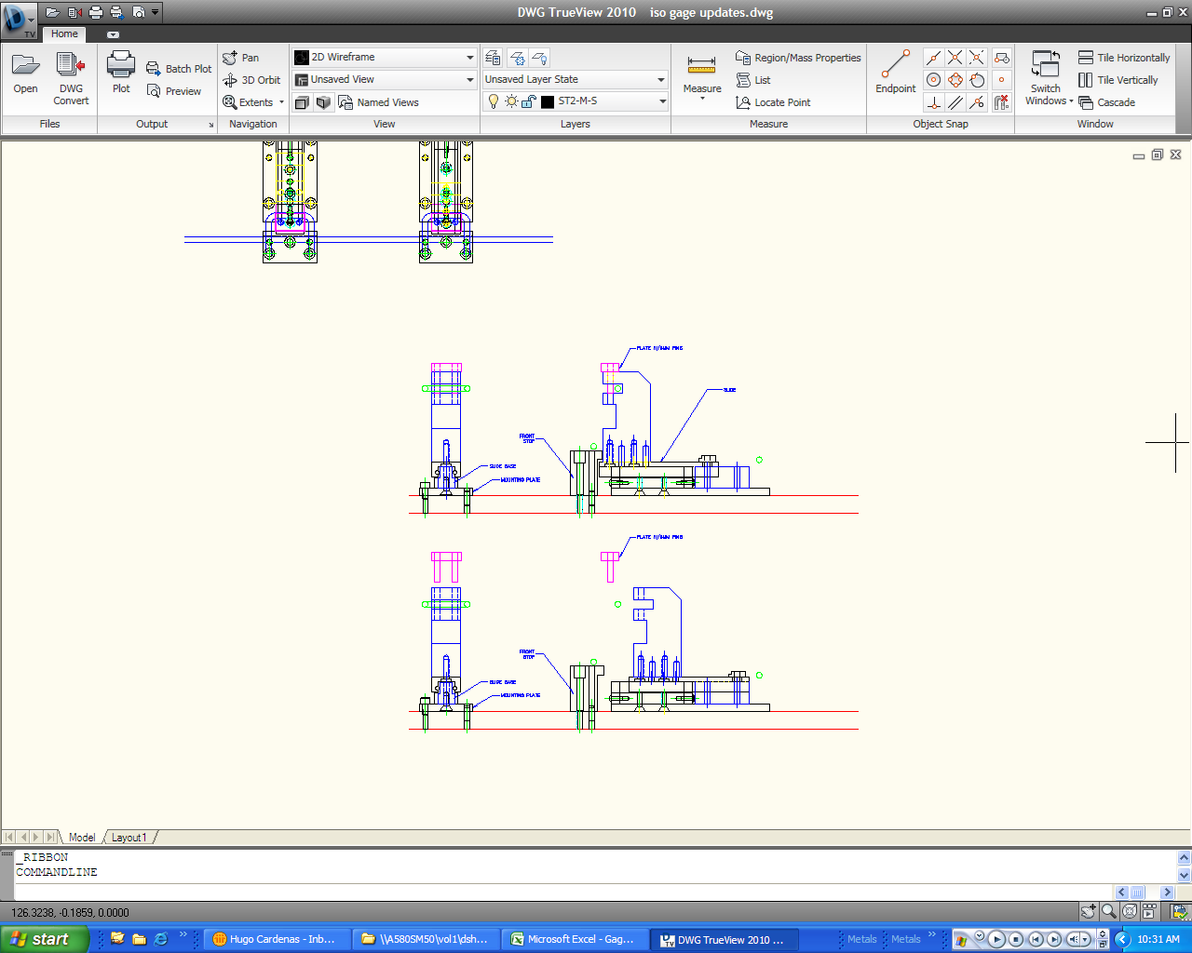

THIS IS FOR SUB ASM OR ASM GAGES, IT CAN BE A SLIDE INTO PLACE OR LEFT INTO PLACE TYPE DESIGN FOR THE GAGE. THE SECONDARY TRUE POSITION IS A HAND HELD TYPE GAGE.

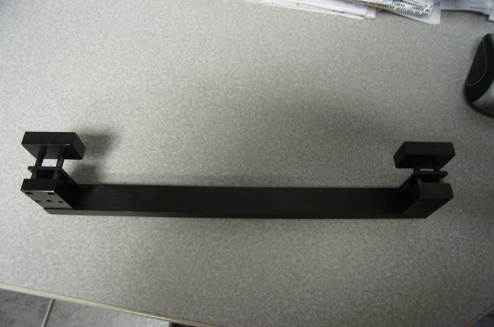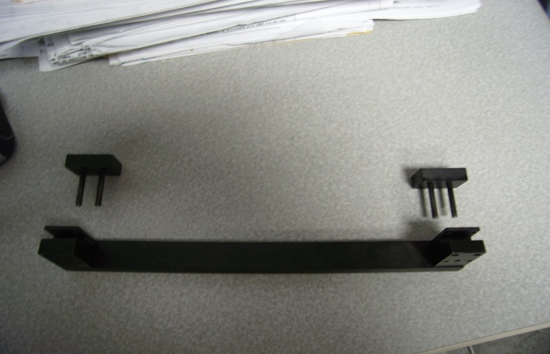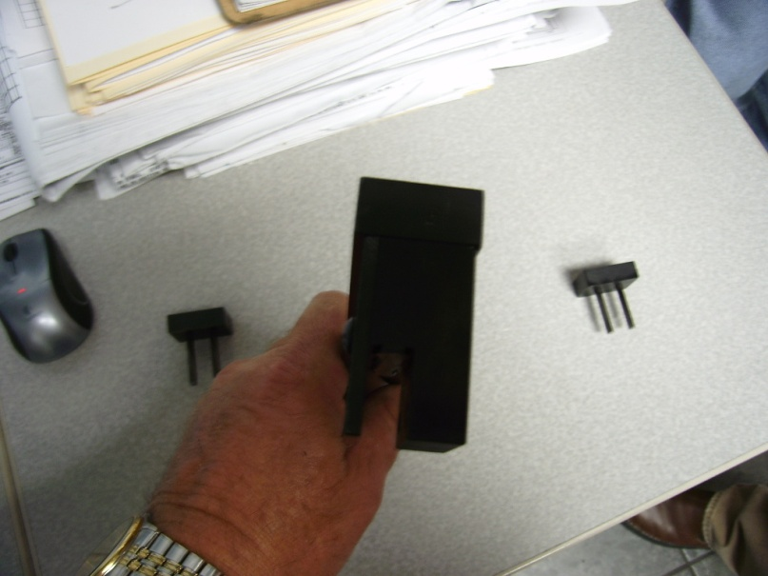
ISOWire hand held gage for True position secondary

Note
Add handle

Add Cables

Hand held ISOWire True Position wire to each other (secondary call out)
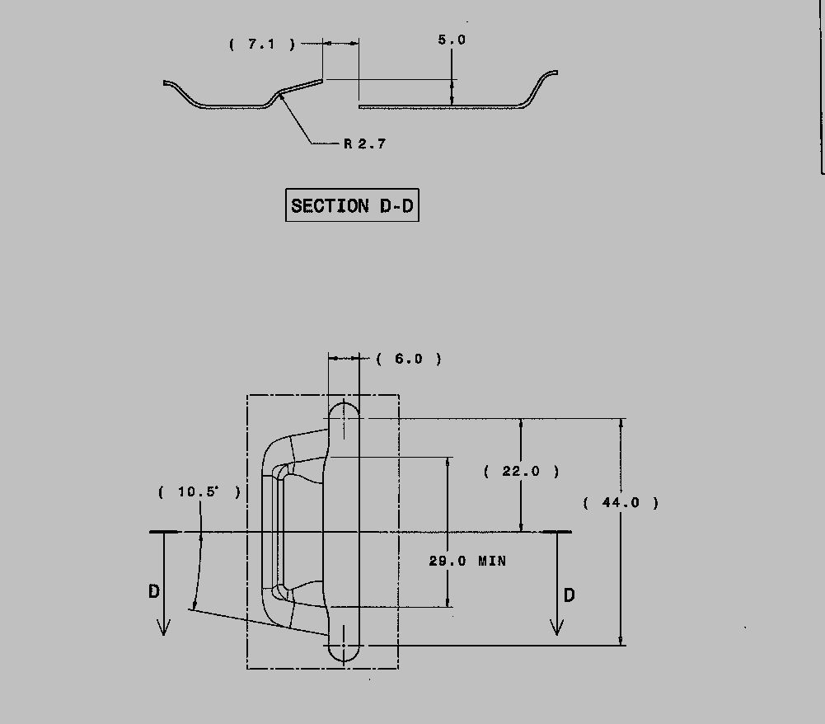
J-Clip Slots – Not identified on drawing as a gagging item. These are a customer issue for no build, pin must be added to gage to check the open as in section D-D for the length indicated.
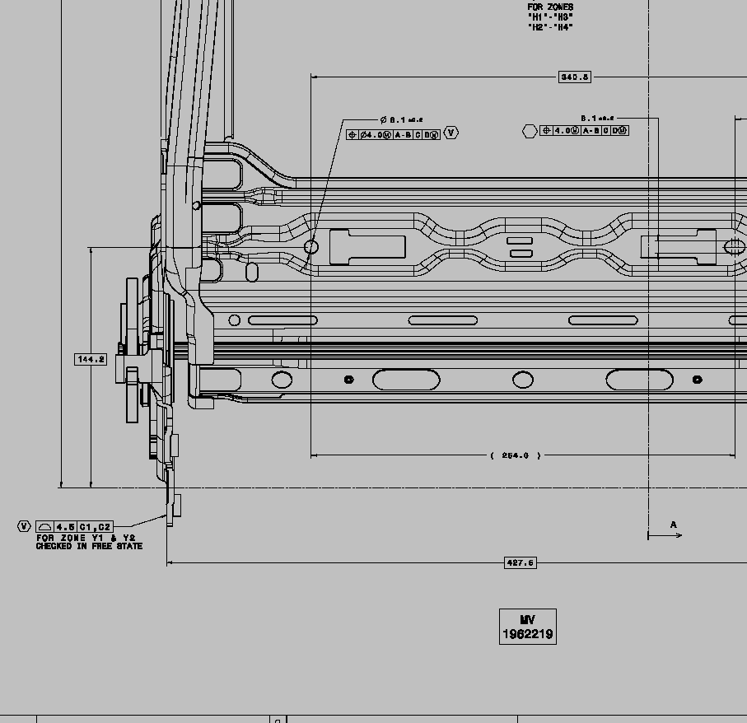

Using the Profile note to check toe in/toe out condition of recliner bracket front to back should be a free state variable check to measure overall width. Suggest method is a large caliper but other methods are acceptable but must be approved.
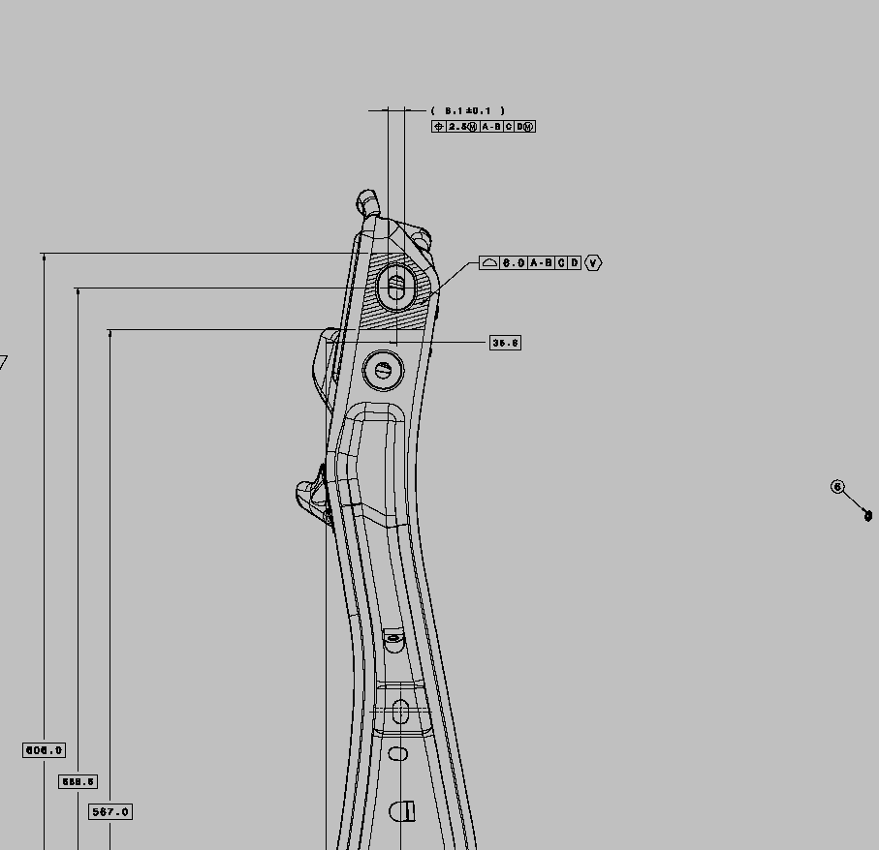

Upper Structure check for True position, once datum pins are applied this true position pin must be inserted first before any other checks are made and left in the assembly during the remaining checks.

